**2022-2023**

**FDLRS Miccosukee**

**Gifted Endorsement**

**Online Courses Schedule**

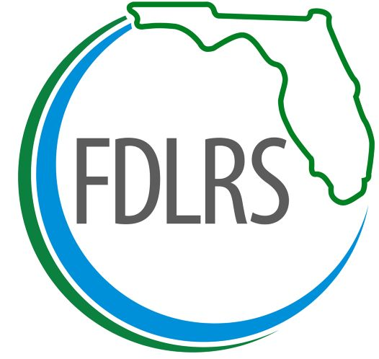

FDLRS is offering GIFTED courses **FREE** to teachers in our FDLRS Miccosukee districts:

**Gadsden, Jefferson, Leon, Taylor, Wakulla, FSUS, and FAMU**

The Gifted Endorsement is designed to increase the level of knowledge, expertise, and understanding of educators working with students who are gifted. The endorsement is intended to raise the awareness of the unique characteristics, emotional and social needs, and other challenges associated with students who are gifted. The courses were designed to foster an understanding of historical, state and national trends, policies, and guidelines to ensure implementation of appropriate academic curriculum, differentiation strategies, educational interventions, and support for this diverse population.

**Each course is worth 60 hours towards the 300 hours required for the Gifted Endorsement.**

**The courses listed below will satisfy 180 hours of the** **300 hours needed to obtain the Gifted Endorsement.**

**Please note that Guidance and Counseling for the Gifted and Education of Special Populations of Gifted Students will be offered at a later date to satisfy the additional 120 hours needed to obtain the Gifted Endorsement (300 hours.)**

**Each online gifted endorsement course are hybrid courses with two virtual face to face meetings.**

**Courses may be taken in any order**. [Click Here to Register](https://reg.gosignmeup.com/reg/event_page.aspx?ek=0010-0030-96f2a0465b0f467287b13b77a3ba34b5)

|  |  |
| --- | --- |
| **Curriculum and Instructional Strategies for Teaching Gifted Students –**  This course provides an analysis of curriculum modifications for gifted learners based on the National Association of Gifted Children (NAGC) Standards for Graduate Programs in Gifted Education. | **Course Dates:**  6/20/22-9/9/22  **Registration Dates:**  6/1/22 – 6/13/22 |
| **Nature and Needs of Gifted Students** – This course provides an overview of gifted education on the national, state, and local level. Cognitive, social, and emotional characteristics common to individuals who are gifted are identified, along with strategies that can be used to meet the academic needs of different categories of students who are gifted. | **Course Dates:**  9/26/22 – 12/2/22  **Registration Dates:**  9/1/22 – 9/19/22 |
| **Theory and Development of Creativity for the Gifted** – This course provides an overview of the theory, research, practical strategies, and resources on creativity, with an emphasis on classroom application in the gifted classroom. | **Course Dates:**  1/17/23 -3/24/23  **Registration Dates:**  1/1/23 – 1/10/23 |

**For additional information, please contact Janie Register:**

**850-561-6545 or** [registerj@leonschools.net](mailto:registerj@leonschools.net)

FDLRS is funded by the Florida Department of Education, Division of K-12 Public Schools, Bureau of Exceptional Education and Student Services, through Federal assistance under the Individuals with Disabilities Education Act, Part B, and State General Revenue funds.